Market Segmentation

**Analysing the respective market in India using Segmentation analysis for Ed-tech learning platforms**

***by***

**Group 2**

**Shardul**

**Madhurya**

**Mohit wani**

# Overview

EdTech may be a divisive subject. Because a big component of the education system is unionised, there are fears that EdTech is an attempt to save expenses by phasing out some in-class activities. EdTech proponents stress the software's and technology's ability to boost learning, allowing teachers to take on more of a facilitator role. With limited time, it's challenging for a teacher to follow the curriculum, catch up with lower-level students, and keep the rest of the class involved in their work. EdTech can possibly lead to improved outcomes for individual students and the class as a whole by automating the evaluation of aptitude and modification of difficulty.

There were two phases of deployment of technology in the classroom. The first step was to bring hardware into the classroom. Eventually, the discussion shifted to how to improve the software to better coordinate and use all of the hardware. EdTech is the term for these software solutions. Many of them are cloud-based and use educational research to determine how slowly or quickly a learner should go through various learning objectives.

Massive Open Online Courses (MOOCs) are a type of online course that uses technology to reach a large number of students all over the world. While these courses have their own set of problems, such as poor completion rates, they are an attempt to give knowledge in a manner that is convenient for the user.

**Clustering implementation Overview:**

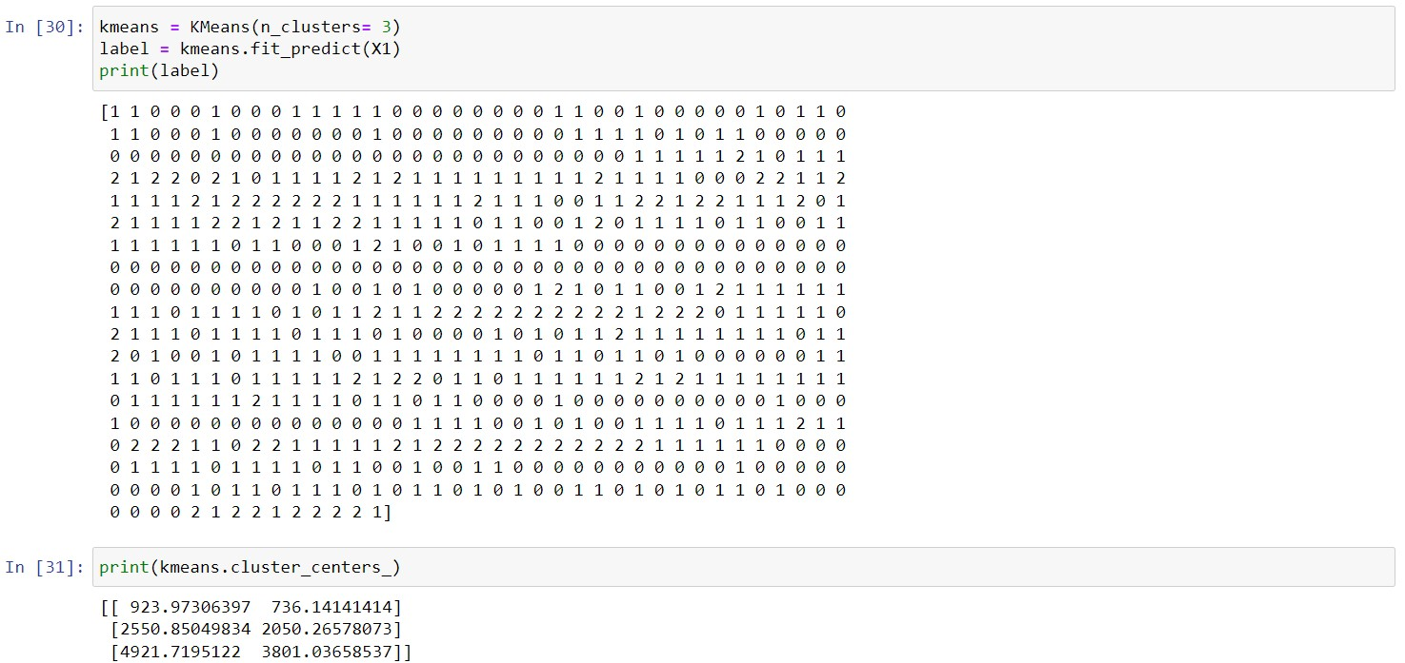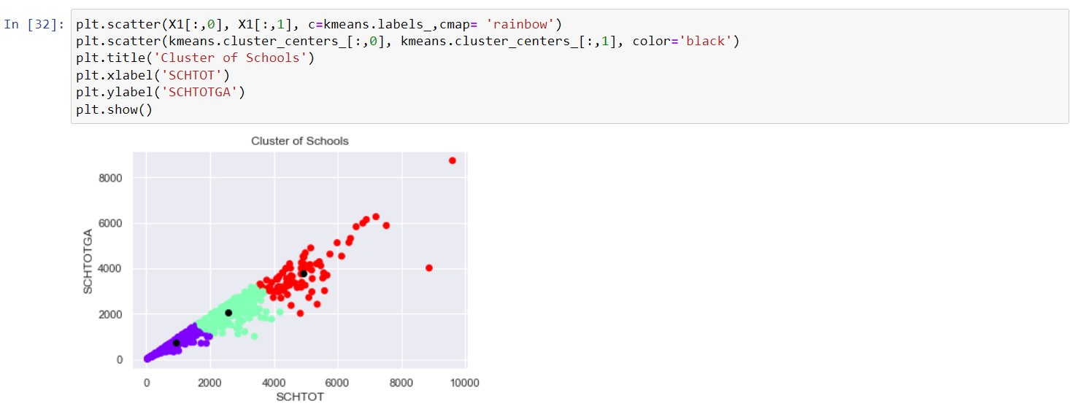

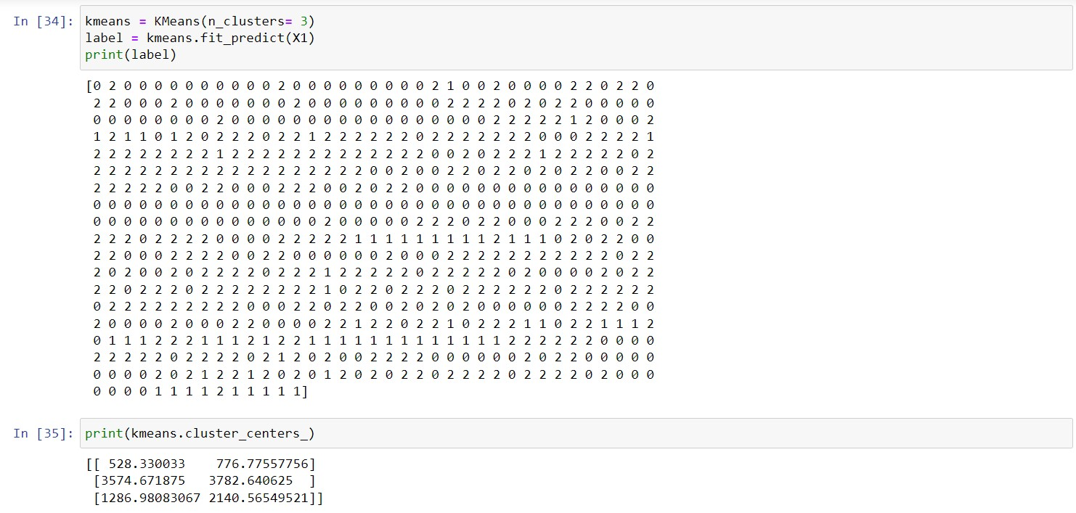

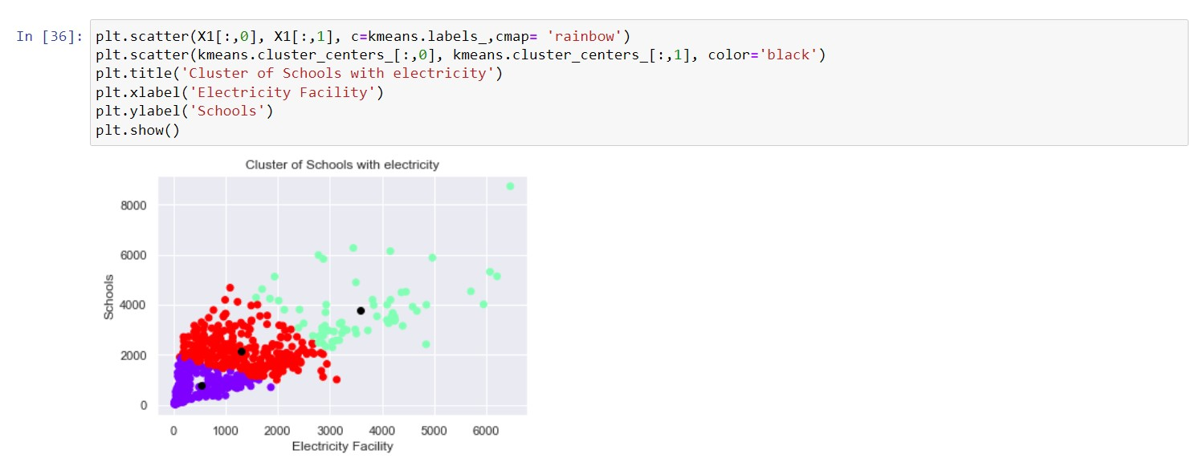

# Market Segmentation

The market is divided into two segments based on hardware: interactive displays and interactive projectors. The interactive displays segment is expected to have the largest share in the global education technology (EdTech) market because these displays help to increase learner engagement and encourage student enthusiasm for learning. Furthermore, by the end of 2030, the increased use of interactive displays to exhibit material such as photographs, movies, and video calls is expected to boost growth in this market sector. Furthermore, the K-12 segment is expected to have the greatest share, owing to the growing trend of game-based learning for children in kindergarten through grade 12, as well as the increased usage of new technologies are used.

The continuous expansion of internet connectivity throughout the world, as well as various technical breakthroughs like as 5G, blockchain, cloud services, Internet of Things (IoT), and Artificial Intelligence (AI), have bolstered economic growth tremendously in the previous two decades. Globally, more than 4.5 billion people were actively using the internet as of April 2021. Furthermore, the rise of the ICT industry has contributed greatly to GDP growth, worker productivity, and R&D investment, among other economic shifts in many countries throughout the world.

Furthermore, the ICT sector's creation of goods and services contributes to economic growth and development. ICT good exports (percentage of total good exports) increased from 10.816 in 2015 to 11.536 in 2019, according to data from the United Nations Conference on Trade and Development's database. In 2019, these exports in Hong Kong SAR, China were 56.65%, 25.23 percent in East Asia & Pacific, 26.50 percent in China, 25.77 percent in Korea, Rep., 8.74 percent in the US, and 35.01 percent in Vietnam. These are some of the key aspects that are propelling the industry forward.

# Situational Analysis

##### Environment

The development and production of digital gadgets has a negative impact on the environment. Between 70% and 80% of the energy consumed over the lifespan of a digital item happens during their initial fabrication, regardless of how they are actually utilised in a classroom. The manufacture of any digital technology "needs a large global network," as Crawford and Joler's forensic "anatomy" of Amazon's Echo device demonstrates, to permit the smelting, processing, and mixing of raw ingredients that are sent halfway around the world to be constructed. Each of these processes entails the accumulation of hazardous waste, hazardous substances, and the disposal of toxic waste.

##### Current Trend in EDTECH:

According to a new research by PwC, virtual reality technology allows pupils to learn more content faster. It will become simpler to bring learning experiences to life as edtech solutions such as video conferencing software grow more flexible and include components of VR and AR.

Bite-size learning modules, live training, and the use of AR (augmented reality) and gamification to make learning interactive are all current educational trends. Institutions are automating their enrollment/admission and student engagement procedures in terms of operations.

 The K-12 sector dominated the EdTech market with a 41.2 percent share. In the K-12 sector, game-based learning is expected to become more popular.

##### TARGET MARKET

Marketing teams may adapt their message to a specific set of clients via targeted marketing. The moment at which the marketing mix comes together to determine the optimum offer and marketing approach for each target market is the targeting strategy.

Following the selection of target groups, whether in EdTech or any other industry, the suitable targeting technique is chosen. Your customer and consumer are largely the same when it comes to degree and post grad students, which is rare in the K-12 market. As a result, the communication and approach in both circumstances will be different.

Another consideration is the geographical location. In EdTech, however, every parent, regardless of location, wants their kid to flourish and have the greatest tools to do so. So, in marketing a product, disposable money, access to great education, regional/cultural influences, and content consumption are some crucial differentiators to consider.

# Analysis and Approaches used for Segmentation

**Clustering**

Clustering is a popular exploratory data analysis tool for gaining an understanding of the data's structure. It is the challenge of finding subgroups in data so that data points within the same subgroup (cluster) are extremely similar while data points within other clusters are quite dissimilar. To put it another way, we strive to find homogeneous subgroups within the data so that data points in each cluster are as comparable as feasible based on a similarity metric like euclidean-based distance or correlation-based distance. The choice of the similarity metric to utilise depends on the application.Clustering analysis may be done based on features (identifying subgroups of samples based on features) or samples (finding subgroups of samples based on samples) (finding subgroups of features based on samples).

# K Means Algorithm

The K Means method is an iterative technique that attempts to divide a dataset into pre-defined separate non-overlapping subgroups (clusters), with each data point belonging to just one of these groups. It attempts to make intra-cluster data points as comparable as feasible while maintaining clusters as distinct (far) as possible. It distributes data points to clusters in such a way that the sum of the squared distances between them and the cluster's centroid (arithmetic mean of all the data points in that cluster) is as little as possible. Within clusters, the less variance there is, the more homogenous (similar) the data points are.

The following is how the k means algorithm works:

1. Determine the number of clusters (K).

2. Initialize the centroids by shuffling the dataset first and then picking K data points at random for the centroids without replacing them.

3. Continue iterating until the centroids do not change. i.e. the clustering of data points does not change.

Expectation maximisation is the method used by k-means to solve the issue.

The data points are assigned to the nearest cluster in the E-step. The centroid of each cluster is computed in the M-step. A breakdown of how we can solve it mathematically may be seen below.

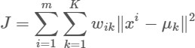

And M-step is:

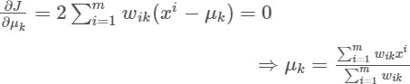

**Applications**

The K means technique is widely utilised in a range of applications, including market segmentation, document clustering, picture segmentation, and compression, among others. When we do a cluster analysis, we normally want to achieve one of two things:

1. Gain a clear understanding of the structure of the data we're working with.

2. Cluster-then-predict, in which various models are developed for distinct subgroups if we feel there is a lot of diversity in their behaviour.

**Implementation**

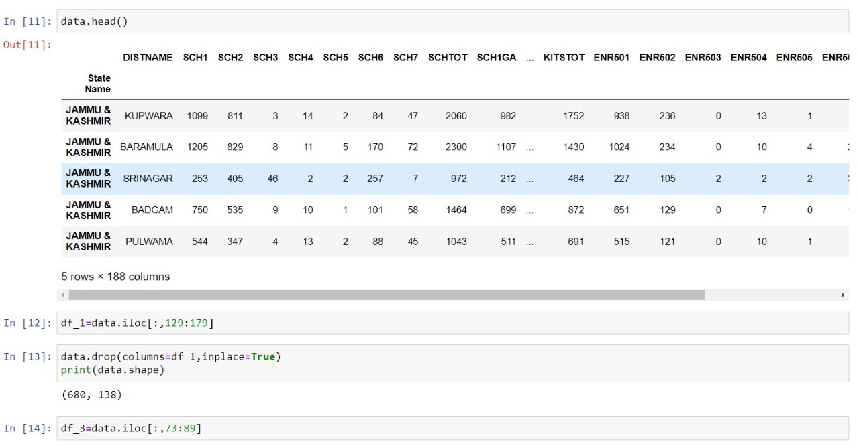

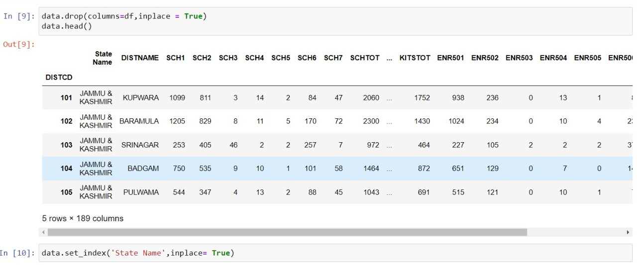

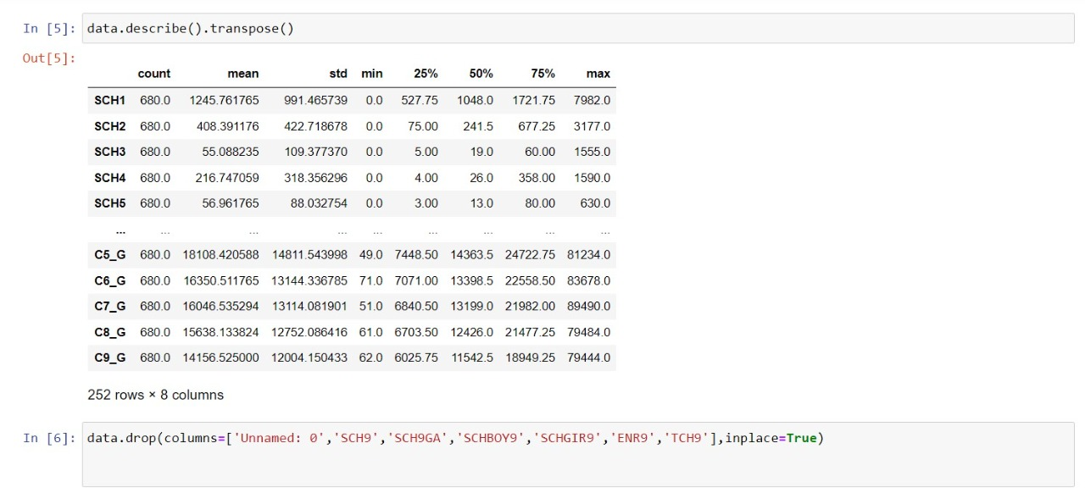

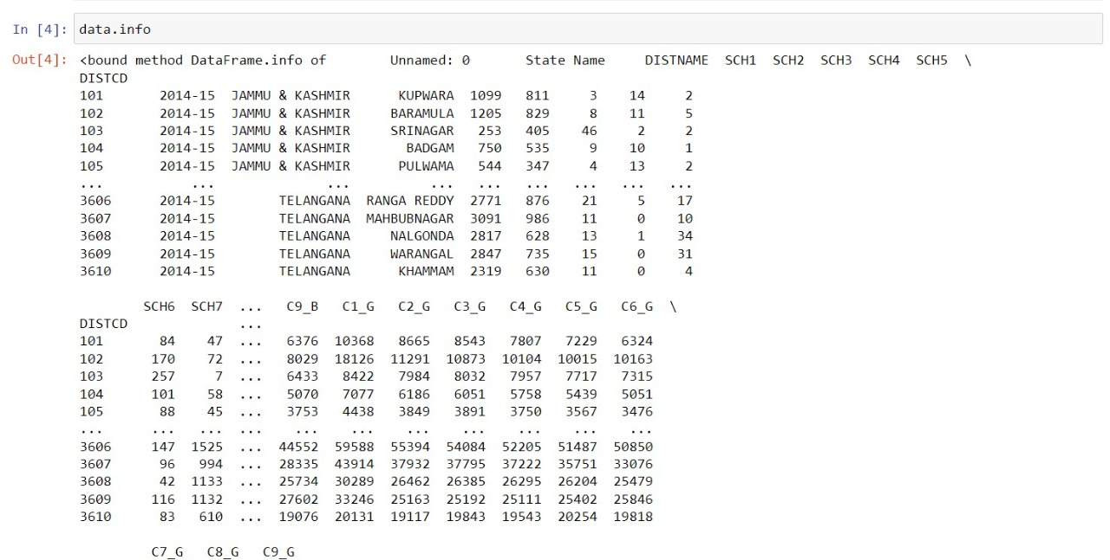

**Segmentation**

Using K Means

And we can use the Elbow method to ﬁnd the optimum K value. For this our plot is something like this.

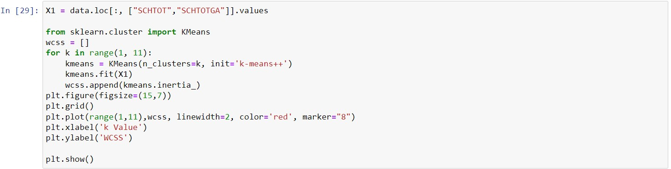

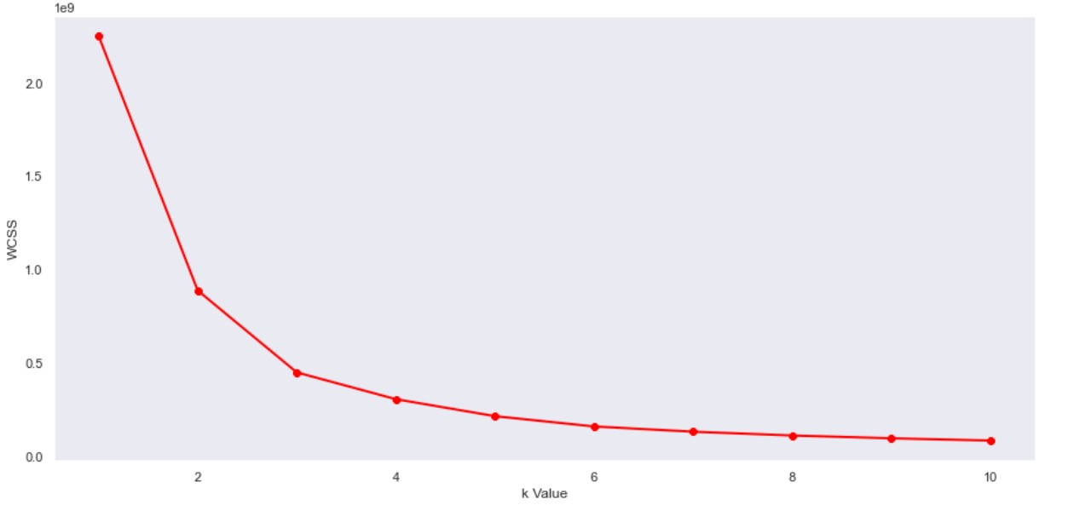

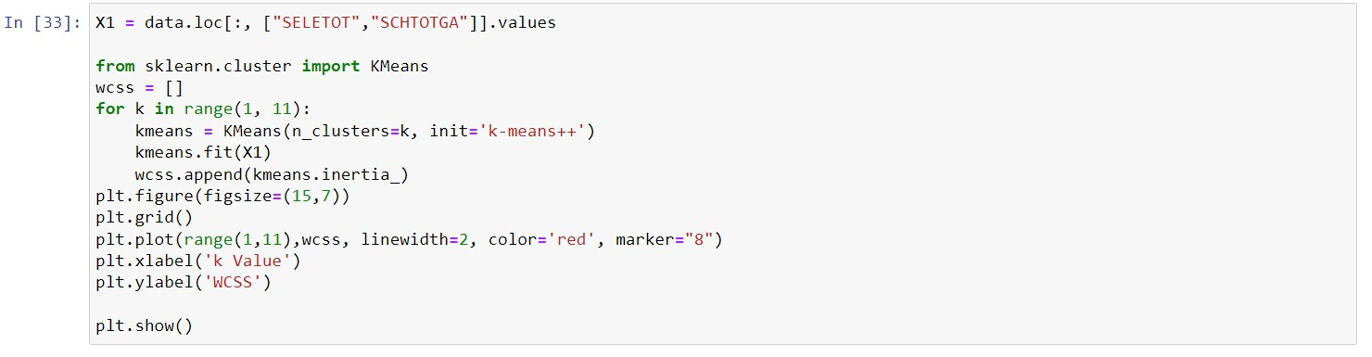

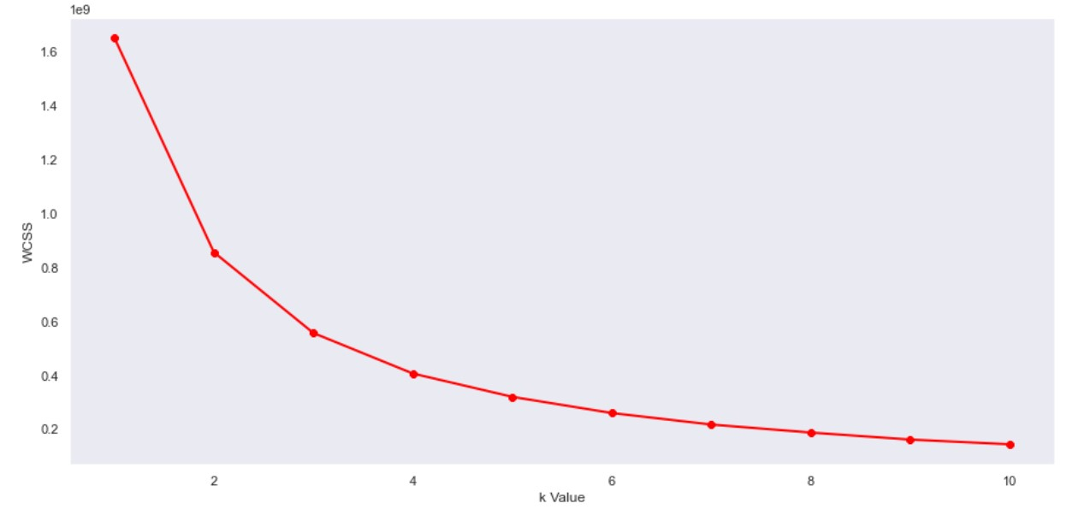

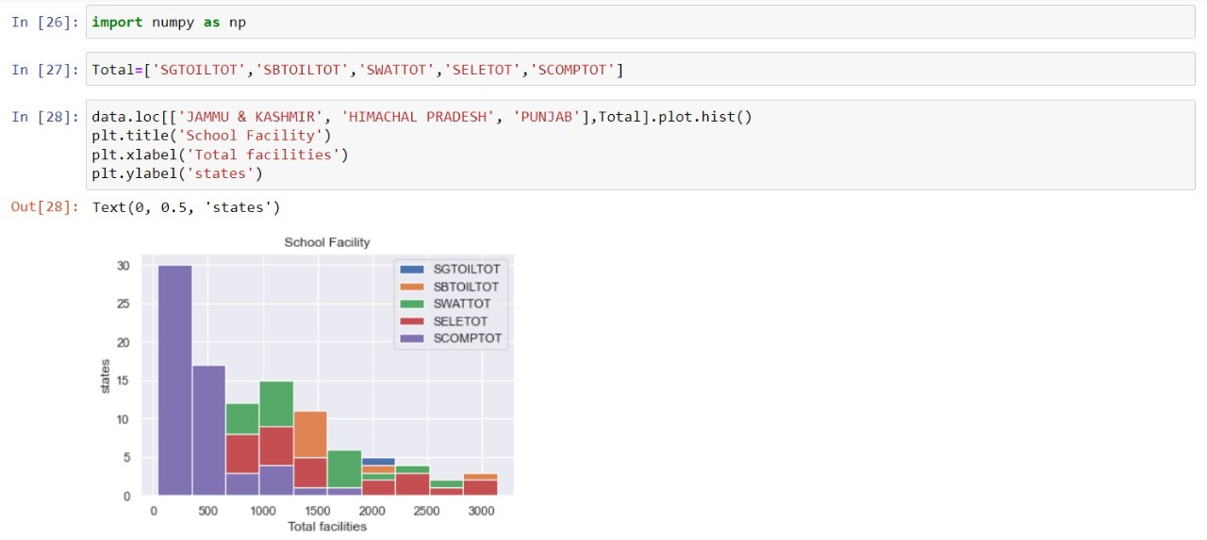

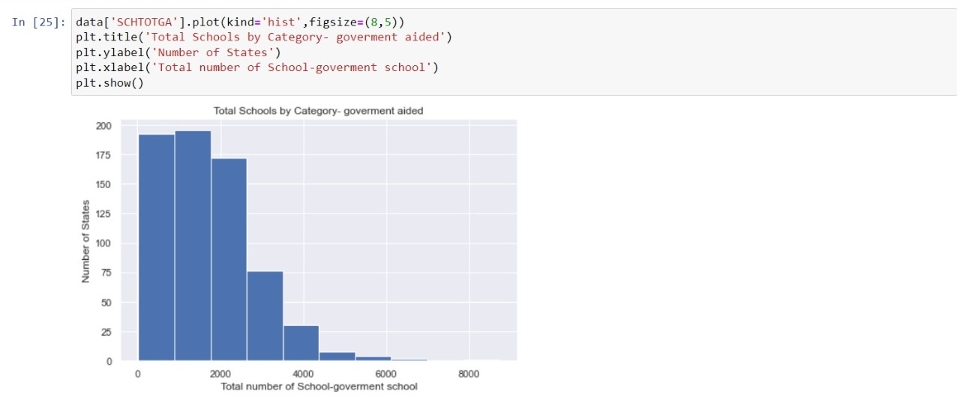

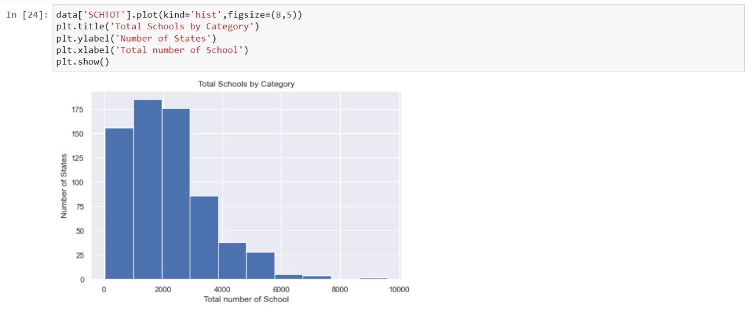

**Codes**

All the codes used in this project can be found on

<https://github.com/SasukeUchiha7/market-segmentation>

# References

Datasets that has been used in this project are taken from

<https://www.kaggle.com/datasets>